MDOD Self-Direction Training User Manual

A step by step navigational process

August 2013

Prepared by: FEi Systems

Contents

1 Access MDOD Self-Direction Training Module 1

2 Create MDOD Self-Direction Training Referral 1

2.1 Create Training Referral from POS 1

2.2 Create Training Referral from Global Referral 2

3 Add MDOD Self-Direction Training Record 3

4 Save MDOD Self-Direction Training Record 5

5 Edit MDOD Self-Direction Training Referral 6

6 Close MDOD Self-Direction Training Referral 6

7 View MDOD Self-Direction Training Report 7

# Access MDOD Self-Direction Training Module

To access MDOD Self-Direction Training module, you must login as permitted user

1. Search for client under *Clients* tab
2. Click **Client Summary** for client
3. Click **MDOD Self-Direction Training** from left navigation under “Case Management”
4. LTSS will bring you to MDOD Self-Direction Training List page and you can choose a record to continue (View or Edit)

Click MDOD Self-Direction Training from left navigation under “Case Management”;
LTSS will bring you to MDOD Self-Direction Training List page and you can choose a record to continue (View or Edit)


# Create MDOD Self-Direction Training Referral

## Create Training Referral from POS

To add a POS, active CMA selection and Plan of Care are required and you must log in as the permitted user. (Please refer to POS User Manual for details)

1. Log in as the permitted user
2. Search for client under *Clients* tab
3. Click **Client Summary** for client
4. Click **Plan of Service** from left navigation under “Program”
5. Click **Add POS**

Click Plan of Service from left navigation under “Program”, then click Add POS


1. Enter **Self-Direction** Information: select “**Yes**” for “**Does the participant want to receive training on how to select, manage, and dismiss attendants?**”

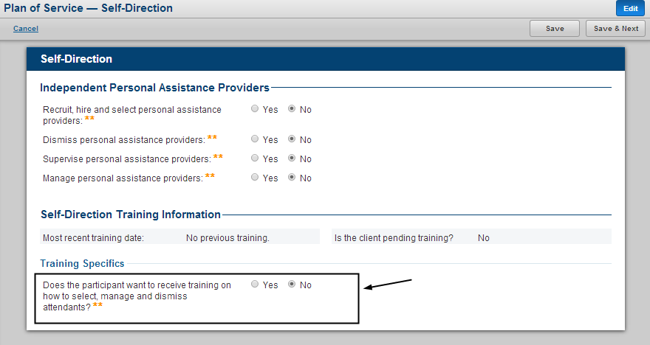

1. Complete and submit POS
2. A pending MDOD Self-Direction training referral will be created

## Create Training Referral from Global Referral

To create a referral from **Global Referral**, you must log in as the permitted user.

1. Log in as the permitted user
2. Search for client under *Clients* tab
3. Click **Client Summary** for client
4. Click **Global Referral** from left navigation and then click “Create Referral”
5. Select **MDOD Self-Direction Training** from **Referral Type** drop-down List
6. Click **Go**

Click Global Referral from left navigation and then click “Create Referral”;
Select MDOD Self-Direction Training from Referral Type drop-down List;
Click Go


1. Complete referral form and click “**Save &** **Submit”**

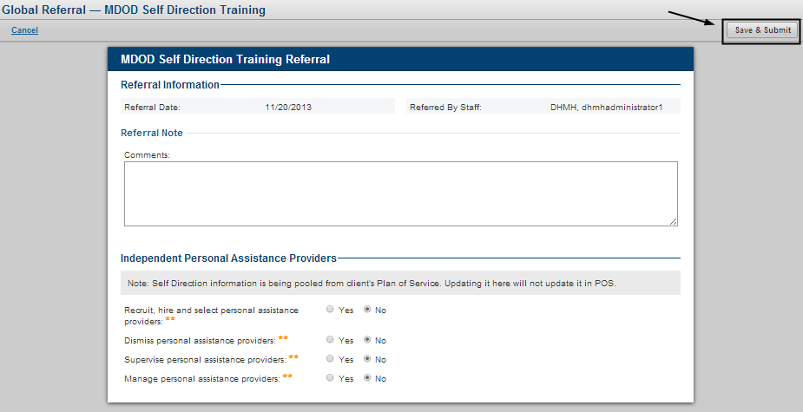

1. A pending MDOD Self-Direction training referral will be created

# Add MDOD Self-Direction Training Record

To add a MDOD Self-Direction Training Record, a **Pending** training referral is required and you must log in as the permitted user.

1. Access **MDOD Self-Direction Training** module
2. Select a **Pending** referral and click **View**

1. Click "MDOD Self-Direction Training" from left navigation under "Case Management"
2. Find a pending referral
3. Click "View"

1. Click **Start**

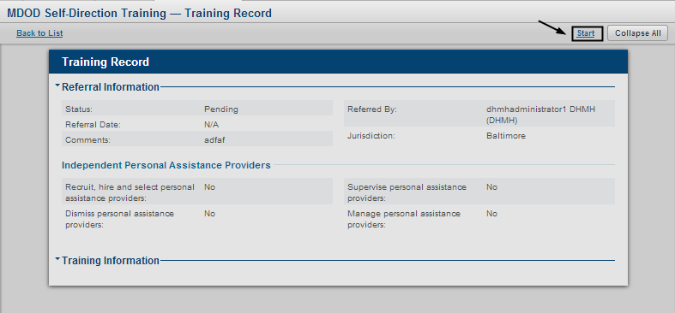

1. You can enter training record now

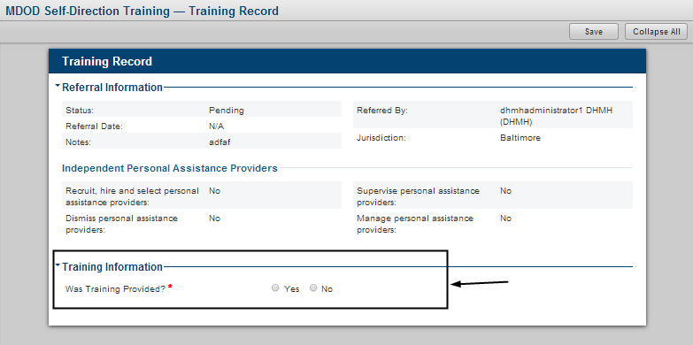

# Save MDOD Self-Direction Training Record

Click **Save** to complete the form process. This will save all previous selections and entries and direct the user to view mode.

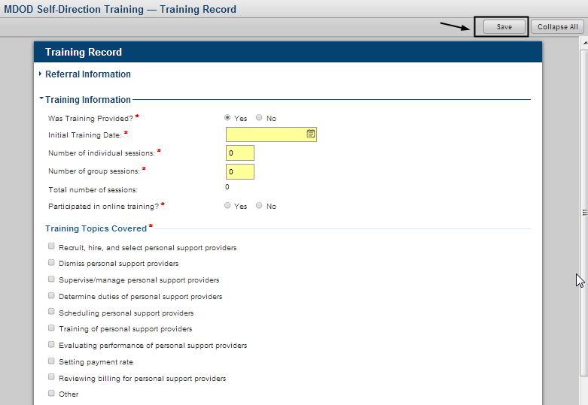

# Edit MDOD Self-Direction Training Referral

To edit a MDOD Self-Direction Training Record, an **In Progress** training referral is required and you must log in as the permitted user.

1. Access **MDOD Self-Direction Training** Module
2. Select an **In Progress** referral and click **Edit**

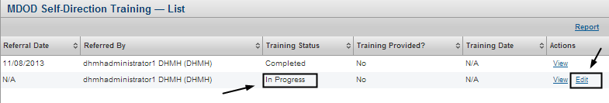

1. You can edit training record now

# Close MDOD Self-Direction Training Referral

To close a MDOD Self-Direction Training Referral, an **In Progress** training referral is required and you must log in as the permitted user.

1. Access **MDOD Self-Direction Training** module
2. Select an **In Progress** referral and click **View**

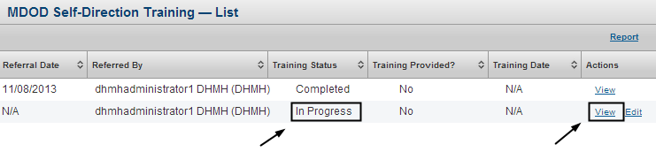

1. Click **Close Referral**

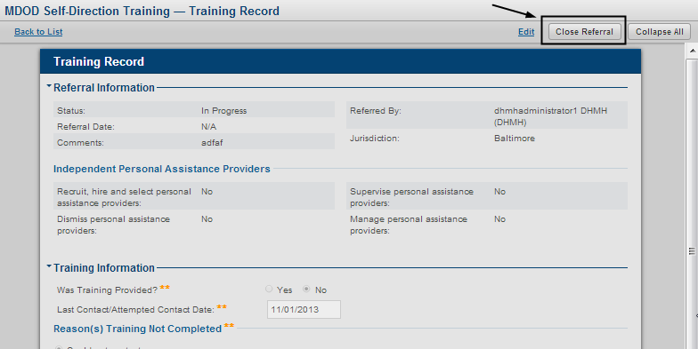

1. Once Referral is closed, referral status is changed to “**Completed**”

# View MDOD Self-Direction Training Report

To view a MDOD Self-Direction Training Report, you must log in as the permitted user.

1. Access **MDOD Self-Direction Training** module
2. Click **Report**

Access MDOD Self-Direction Training module; Click Report


1. Enter **Referral Date From** and **Referral Date To**
2. Click **Filter**

1. Enter Referral Date From and Referral Date To
2. Click Filter


1. You can view MDOD Self-Direction Training Report for selected period now

